**DSD ASSIGNMENT 2**

By: C.P.Sindhu(PES1UG21EC071)

Saksham Singh(PES1UG21EC240)

1. **Free Running Shift Register** 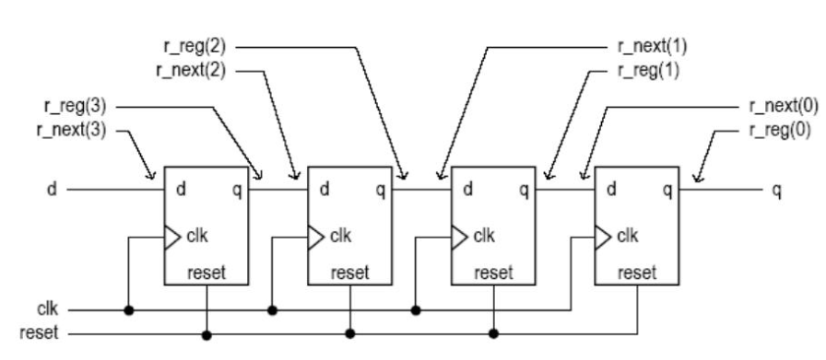

Code:

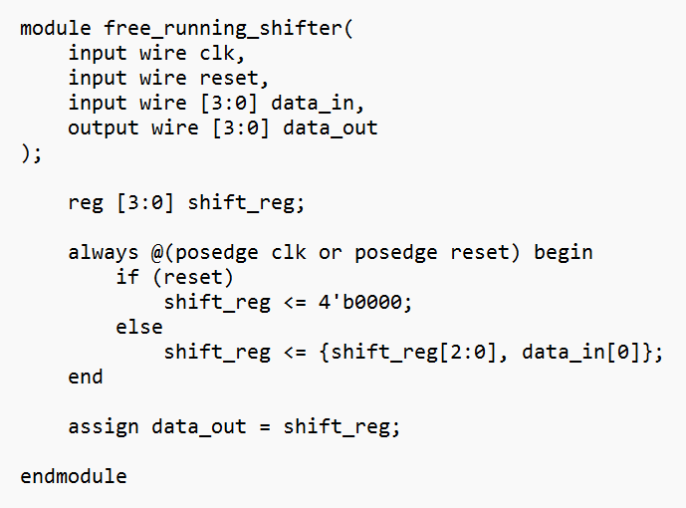

Testbench: 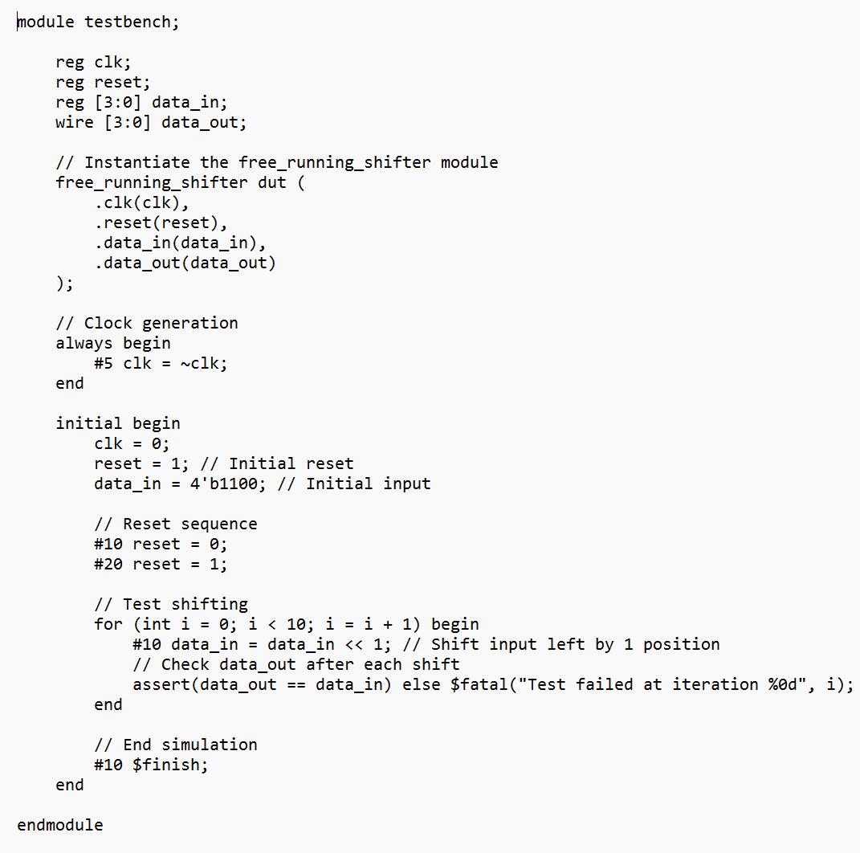

Output: 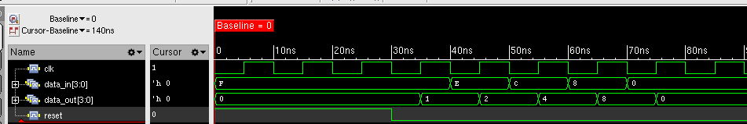

1. **FIFO**

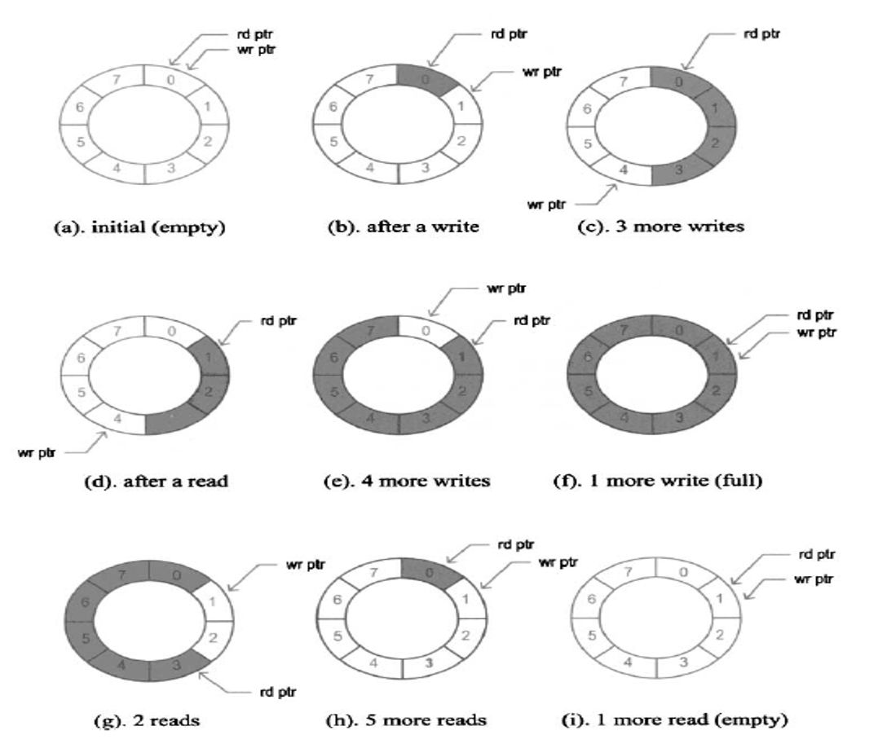

Code: 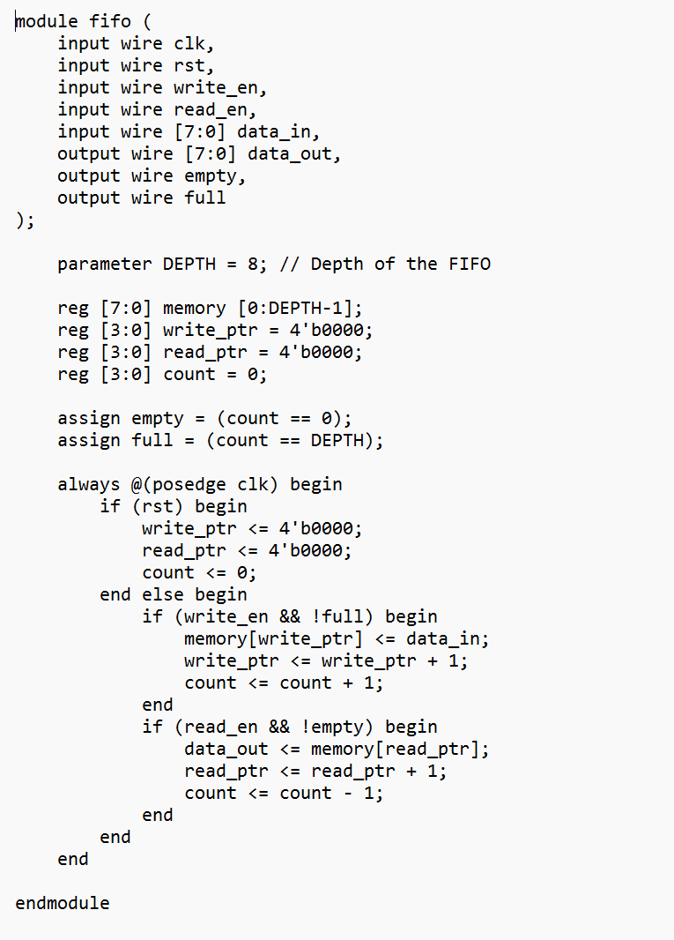

Testbench: 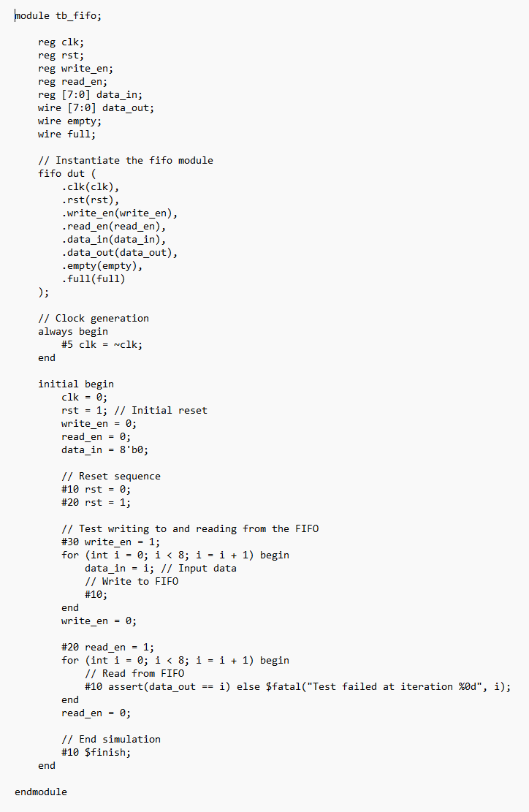

Output: 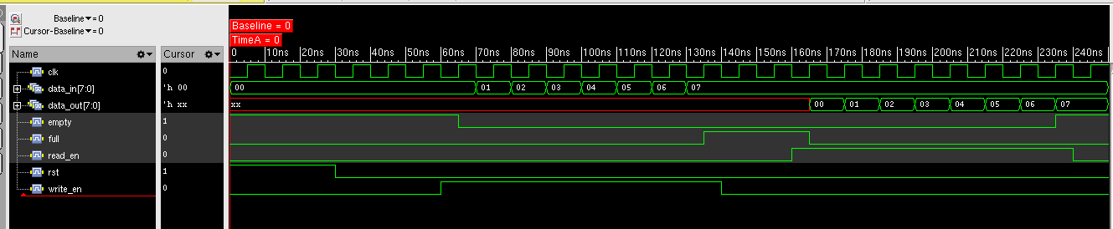

1. **LFSR**

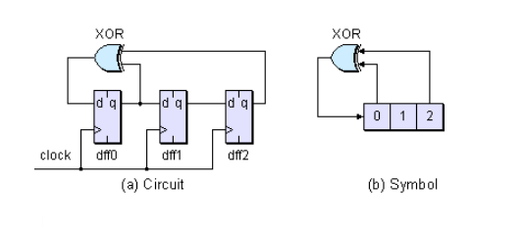

Code:

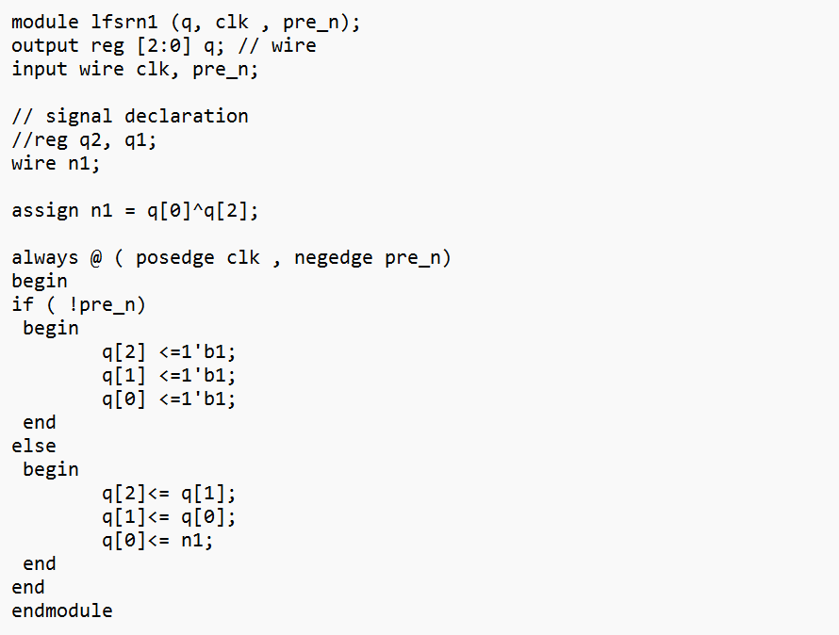

Testbench:

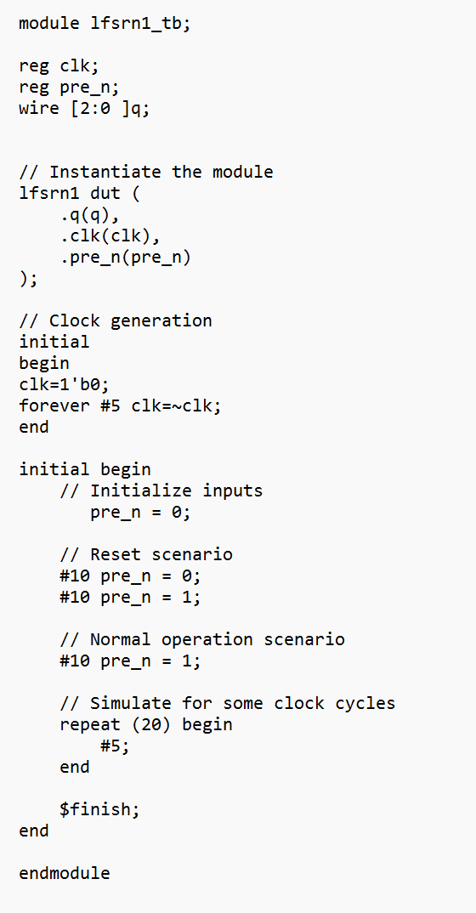

Output:

